What's Up With IDDSI & NDD: Full Disclosure!
LET’S DISCUSS SIMILARITIES & WHAT HAS CHANGED

Mapping 101: Compare NDD or your diet definitions to → IDDSI.
1. Determine where your diet names and what is served fall under the “Current NDD Food Textures” column.
2. Align the NDD diet name to the IDDSI name by comparing what is recommended or not recommended to be served.
3. Consider the descriptions of patient abilities when comparing. Both NDD and IDDSI state what the patient's abilities or difficulties are at each level/diet name.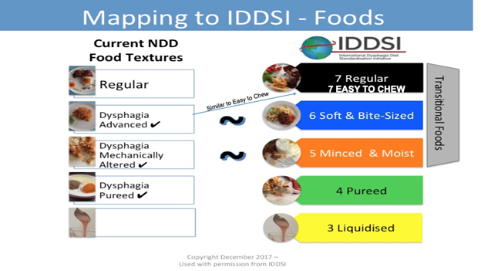

NDD Level 1 Pureed → IDDSI Level 4 Pureed (GREEN)
Puree is the same name! The texture definition in both NDD and IDDSI are similar. However, IDDSI lists additional objective puree descriptions and provides the testing methods to assure safety of a pureed food product.
NDD Level 2 Mechanically Altered → IDDSI Level 5 Minced & Moist (ORANGE)

NDD Level 2 description stated: “moist,” “minced,” “cohesive,” and “easily mashed.” However, the NDD name of “Mechanically Altered” was hard to interpret.
The IDDSI name of “Minced & Moist” is what NDD intended, and it is more descriptive of what the kitchens will actually produce. IDDSI provides exact sizes of food pieces (pediatric and adult) consistent with a safe swallow and based on science. Added moisture is a MUST!
NDD Level 3 Dysphagia Advanced → IDDSI Level 6 Soft & Bite Sized (Blue)

NDD description included: “bite-sized,” “soft," “moist," “not sticky," but bite size guidelines were larger than the typical diameter of an airway.
IDDSI Level 6 name, “Soft & Bite Sized,” says it all! And has specific bite-size measurements for safety based on the diameter of the average child and adult trachea.
NDD Level 3 Dysphagia Advanced can also map to IDDSI Level 7 Easy to Chew (Black) - a sub-group of the IDDSI Level 7 Regular

Softer foods are provided on the Level 7 Easy to Chew level and may align closely to NDD Level 3 or with your least restrictive texture modified diet.
There are no size restrictions in IDDSI level 7 Easy to Chew, so the diet does not reduce a choking risk. The safety and suitability of breads & mixed consistencies is assessed on an individual basis. This diet level may be appropriate for those who have dental and/or chewing difficulties without significant dysphagia. It is typically for those who are safe dining independently.

