Common ground between IDDSI & NDD
1. IDDSI and NDD have some similar content (Not all is NEW!).
2. Both are based on food textures and chewing and/or swallowing abilities.
3. NDD’s intention was always to evolve and be revised pending research and best-practice.
4. The old labels (diet names) for liquids easily transition to the new labels. The new labels are more descriptive. Bonus: Now liquids are easy to test with IDDSI Flow Test. 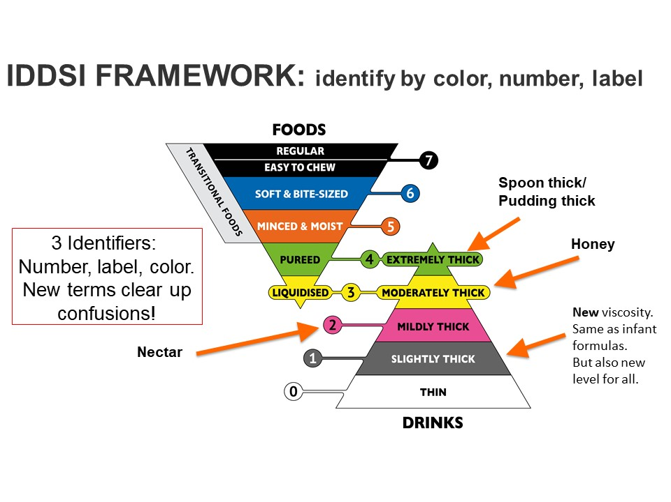
IDDSI Improvements for Safety

1. IDDSI created clearer labels and added more descriptions to the diet levels to assure food safety.
2. IDDSI added 3 descriptors to identify diet levels: Number, Color and Label. This has shown to:
a. facilitate education,
b. allow accurate identification and
c. improve communication.
3. IDDSI’s testing methods use easy-to-access tools, such as spoons, forks or chopsticks.
4. IDDSI builds upon NDD, providing a pathway to “MAP” transition.
a. Define current texture modified diets being used (What is served/not served?)
a. Which current diets align best with each IDDSI level? (Mapping)
b. What are the food and fluid items that currently meet IDDSI standards? (IDDSI Testing)
c. What items require recipes adjusted to produce consistent SAFE food/fluids served?

